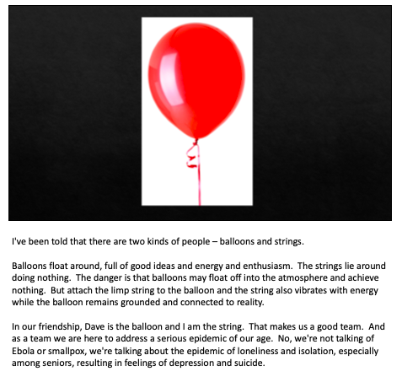
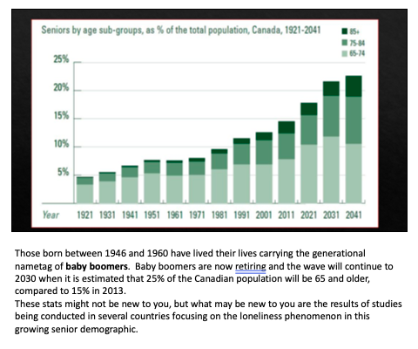
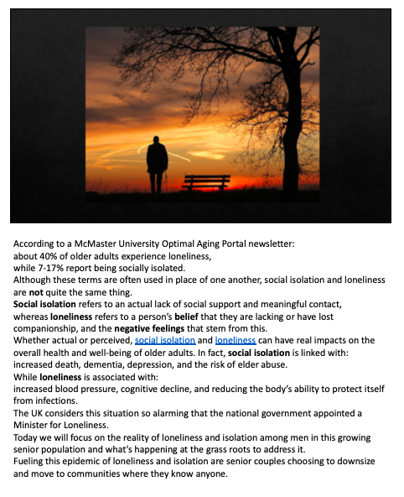
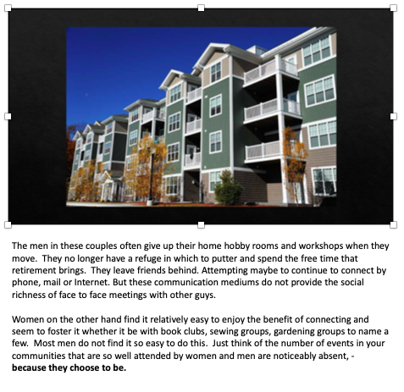
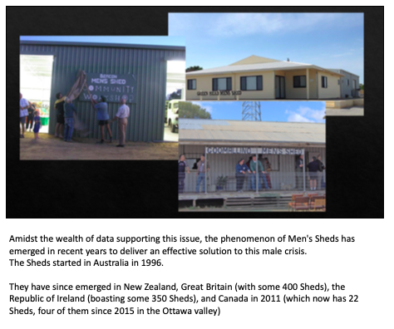
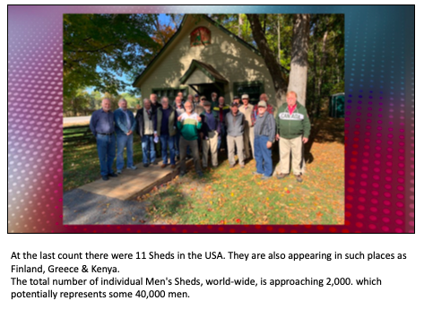
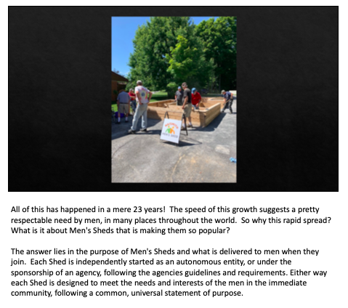
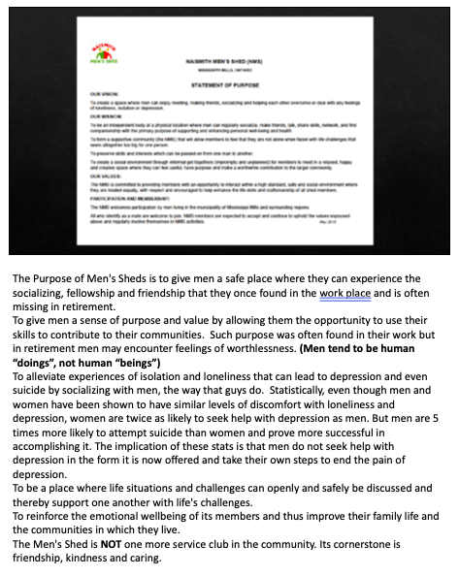
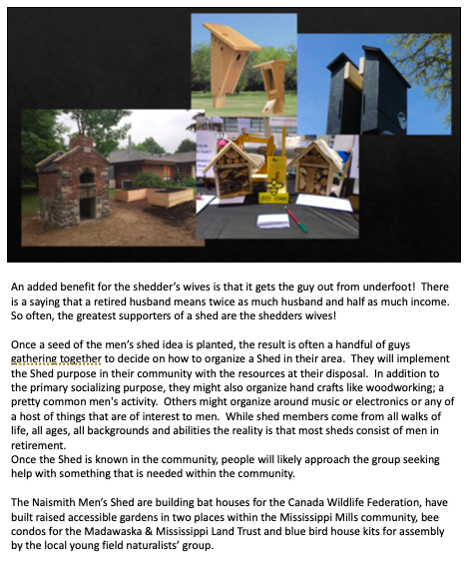
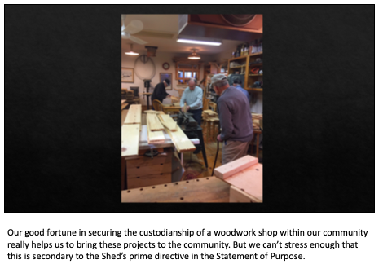
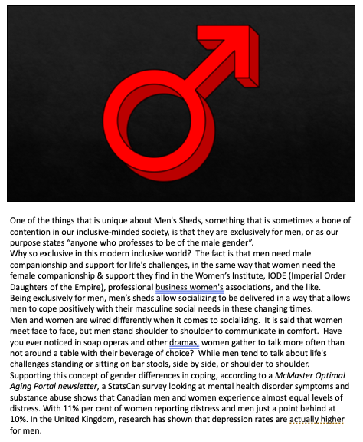
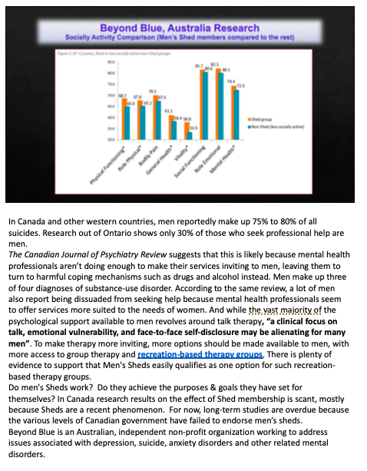
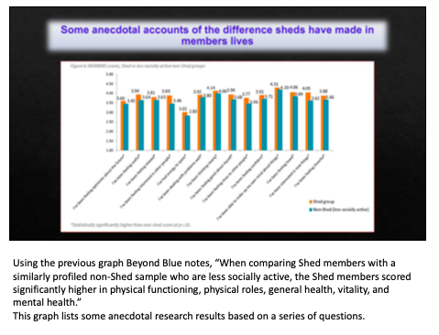
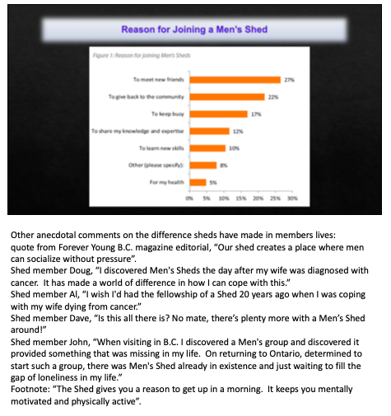
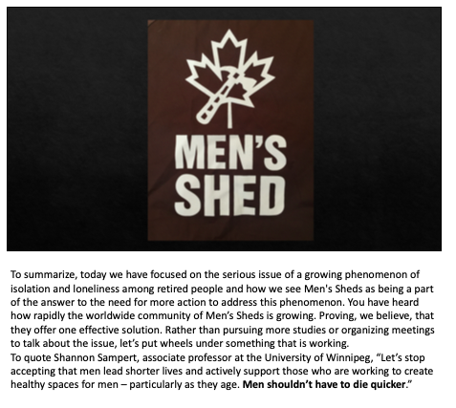
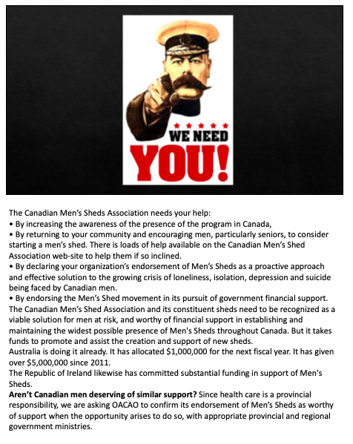
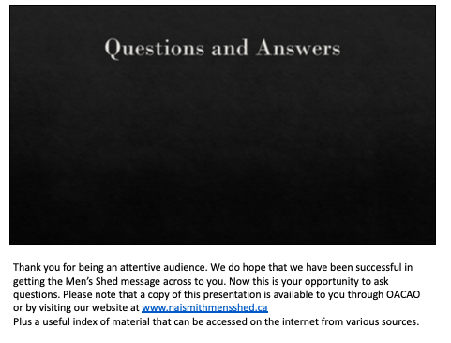
Resource Material on the Topic of Men’s Sheds

• Men's Sheds Canada national website http://menssheds.ca/
• Naismith Men’s Shed website http://www.naismithmensshed.ca
• McMaster Optimal Aging Portal for articles on health among aging Men https://www.mcmasteroptimalaging.org/browse
• Punch Jackson's newsletter re: MS around the world https://paper.li/RecretionCanada/1431485509?edition_id=a2505a50-f130-11e9-82e8-0cc47a0d164b
• article in Good Times Canada’s Magazine for Successful Retirement: https://goodtimes.ca/helping-men-cope-retirement/
• Globe and Mail article Nov 26, 2015 “Men vulnerable to boredom, depression in retirement”
https://www.theglobeandmail.com/globe-investor/retirement/retire-health/men-vulnerable-to-boredom-depression-in-retirement/article27490557/
• Globe & Mail article Sept 21, 2018 “health by stealth” https://www.theglobeandmail.com/life/health-and-fitness/article-mens-sheds-where-guys-tinker-and-improve-health-by-stealth/
• Winnipeg Free Press Aug 3, 2017 “Women get sicker, but men die quicker”
https://www.winnipegfreepress.com/opinion/analysis/mens-sheds-help-build-longer-happier-lives-438248073.html
• The Guardian Newspaper Nov 6, 2013 “Men’s Sheds are more than buildings” https://www.theguardian.com/commentisfree/2013/nov/06/mens-sheds-building-lifesaver-community
• Boston Globe “The biggest threat facing men”
https://www.bostonglobe.com/magazine/2017/03/09/the-biggest-threat-facing-middle-age-men-isn-smoking-obesity-loneliness/k6saC9FnnHQCUbf5mJ8okL/story.html
- CBC “Canada is unprepared for the demographic time bomb hurtling towards us” https://www.cbc.ca/radio/thesundayedition/the-sunday-edition-october-14-2018-1.4858401/canada-is-unprepared-for-the-demographic-time-bomb-hurtling-at-us-1.4860164
- CBC “Loneliness in seniors an epidemic” https://www.cbc.ca/radio/thecurrent/the-current-for-september-20-2016-1.3770103/loneliness-in-canadian-seniors-an-epidemic-says-psychologist-1.3770208
- Government of Canada “Social Isolation of Seniors” https://www.canada.ca/en/employment-social-development/corporate/partners/seniors-forum/social-isolation-toolkit-vol1.html
- Huffington Post “It’s time to get men talking about depression” https://www.huffingtonpost.ca/joshua-r-beharry/world-health-day-male-depression_b_15833732.html
- Beyond Blue “Men are known to bottle things up” https://www.beyondblue.org.au/who-does-it-affect/men
- Evidence Network “Men’s sheds help build longer happier lives” https://evidencenetwork.ca/?s=men%27s+sheds
- Forever Young Magazine “Senior men create a place where men can
socialize without pressure” https://www.foreveryoungbc.com/images/stories/pdfs/FYng_Aug_2018.pdf

